What is authentication and authorization

What is Authentication?

Authentication is the process of verifying who a user is.
✅ Real-Life Analogy:
Imagine you go to the airport. At the entrance, you show your ID and ticket to prove who you are. The security checks your identity — this is authentication.

What is Authorization?

Authorization is the process of verifying what an authenticated user is allowed to do.
✅ Real-Life Analogy:
Now that you're inside the airport, you can only enter the gate listed on your ticket, not any gate you want. Your ticket gives you access to specific areas — this is authorization.

Web Application Example: Admin Dashboard
Scenario:
You have a web application with two types of users:
- 👤 Regular users
- 🛡️ Admin users

🔐 Authentication Example:
User goes to /login page and enters:
- Email: user@example.com
- Password: ********
- The system checks: Does this email exist? Does the password match?
- If yes, the user is authenticated and gets a token (or a session).
💡 Key point: Authentication answers:
✅ "Are you who you say you are?"

🔒 Authorization Example:
Now, the authenticated user tries to access:
- /admin/dashboard
System checks:
- Is this user an admin?
- If yes → grant access
- If no → show "403 Forbidden" error
💡 Key point: Authorization answers:
✅ "What are you allowed to do?"

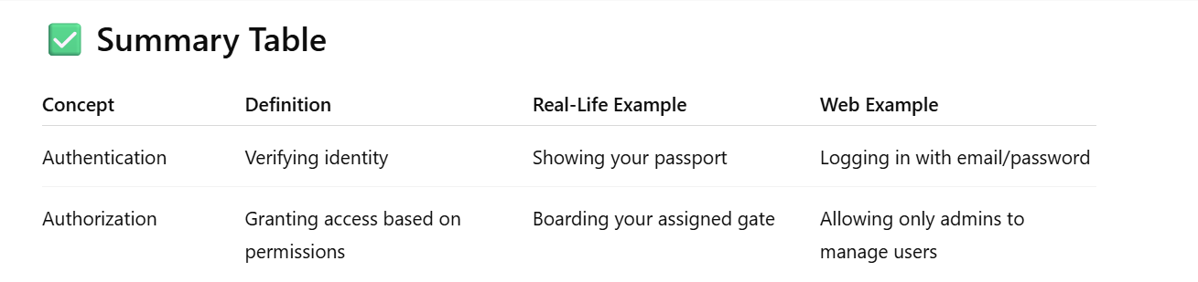

1. Types of Authentications
- Session-based authentication
  - Using express-session and cookies.
  - Suitable for traditional web apps.
- Token-based authentication
  - JWT (JSON Web Token) – most common in REST APIs.
    - Libraries: jsonwebtoken, passport-jwt.
- OAuth 2.0
  - For social login (Google, Facebook, GitHub).
  - Libraries: passport, passport-google-oauth20, etc.

Now we want to discuss about the JWT Token

What is JWT?
JWT (JSON Web Token) is a compact, URL-safe token format used to represent claims between two parties. It is often used for authentication and authorization in web apps.

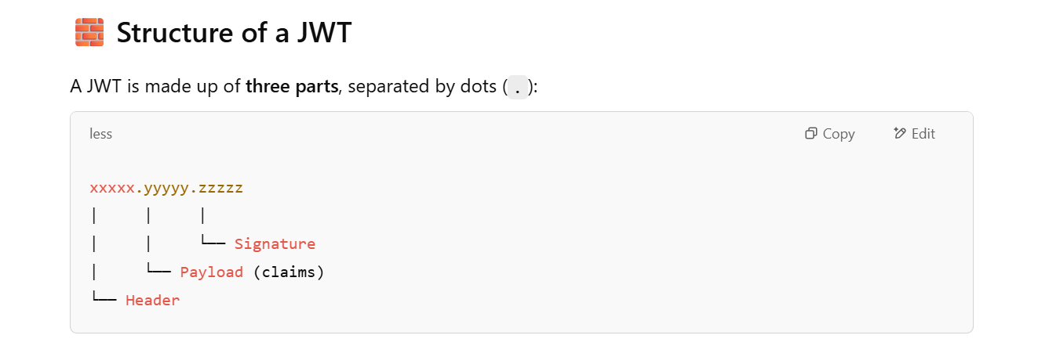

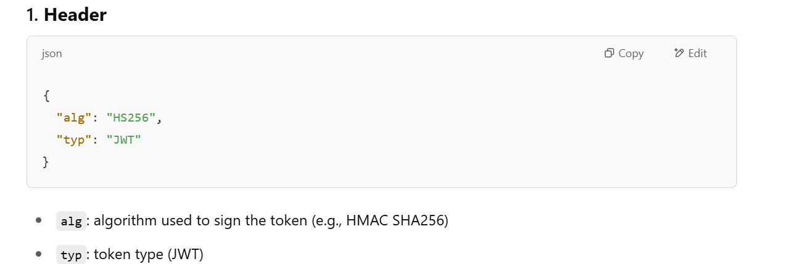

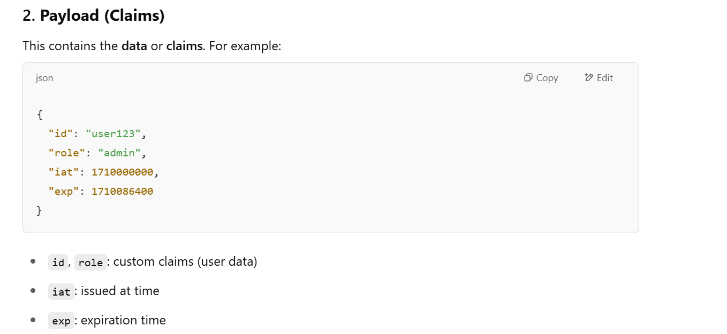

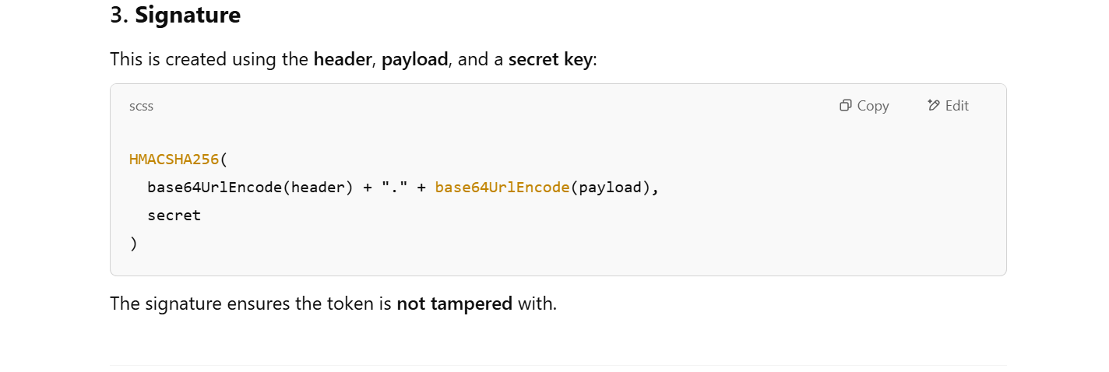

Q. What are the benefits of JWT Token?
Detailed Benefits of JWT
1. Stateless (No Server Memory Usage)
- The server does not need to store any session information.
- All user data is embedded in the JWT and stored on the client.
- Makes it easier to scale horizontally (e.g., across multiple servers or containers).
2. Better for APIs and SPAs
- JWT is ideal for Single Page Applications (SPAs) like React, Vue, Angular.
- Commonly used with RESTful APIs and mobile apps.
3. Easy Cross-Domain or Mobile Authentication
- JWT can be used in cross-domain scenarios, and it’s language/framework-agnostic.
- Works well for mobile apps, where session cookies are less practical.
4. Built-in Expiry
- JWTs have built-in exp claim, so tokens expire automatically after a certain time.
- You can also implement refresh tokens for long-lived sessions.
5. Transportable & Compact
- JWTs are compact (base64 encoded) and can be easily passed in:
  - HTTP headers (Authorization: Bearer <token>)
  - Cookies
  - Query strings (although less secure)

What is difference between JWT Token and session?
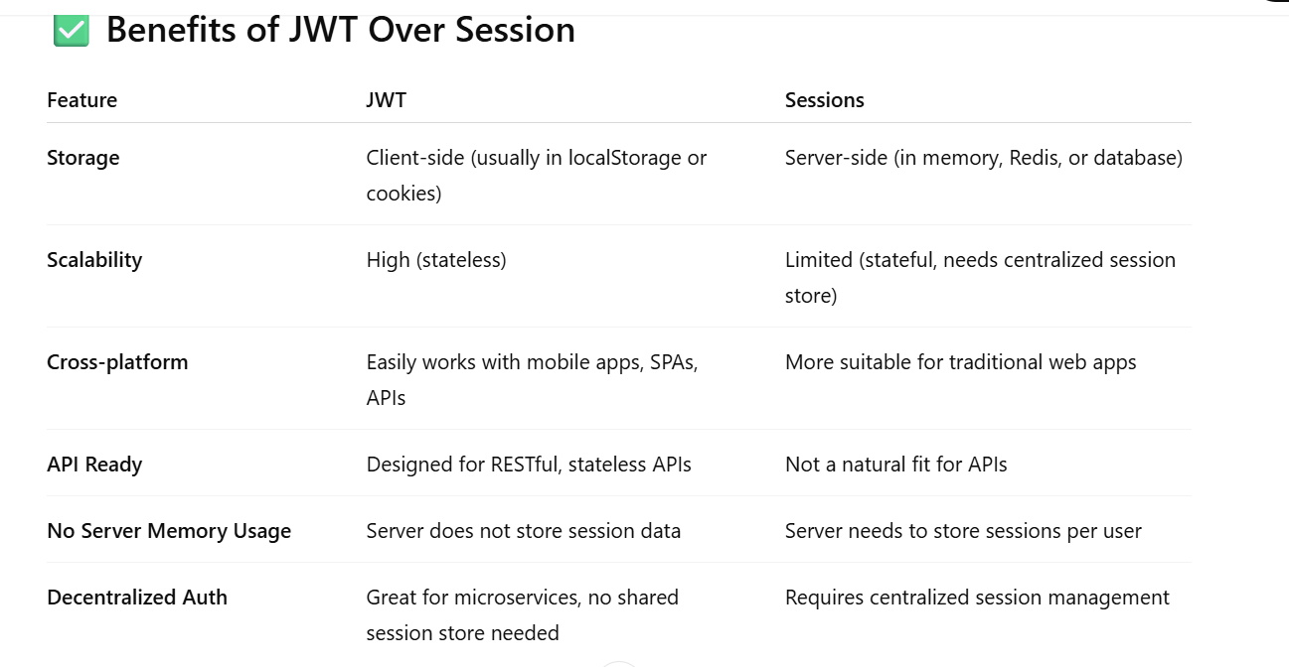

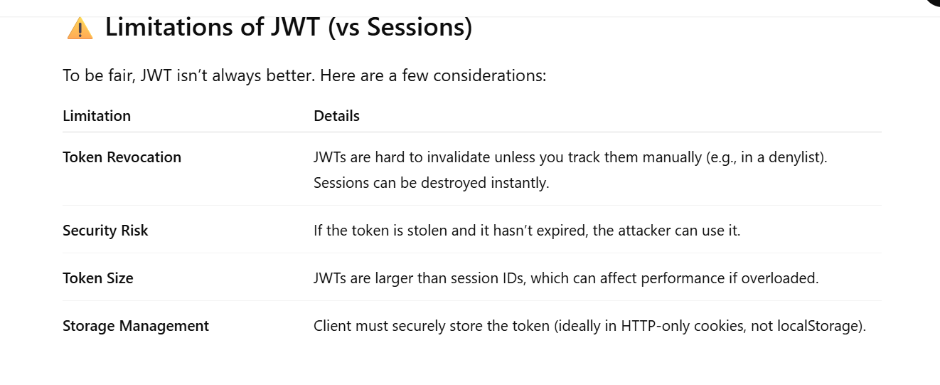

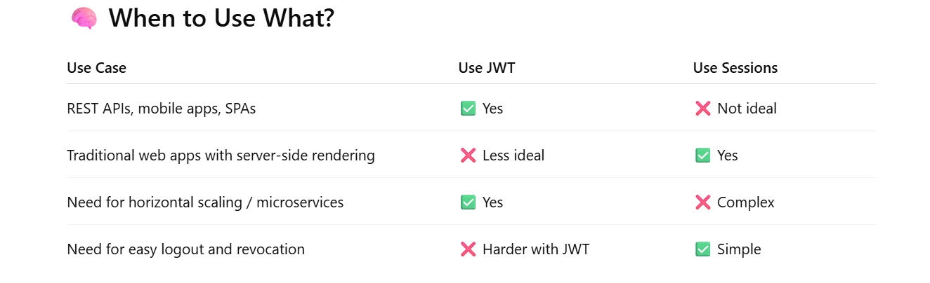

Example with source code
_____________________________________________________________________________
Steps to work with json web token
________________________________________________________________________________
1. Install the jsonwebtoken dependency
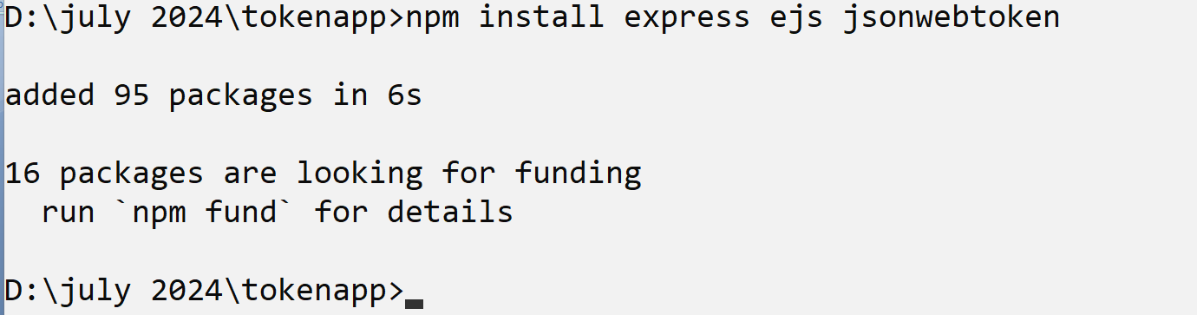

creating jwt webtoken
__________________________________________________________
const jwt = require('jsonwebtoken');
const secretKey = 'abcde12345';

const token = jwt.sign({
id: 1,
username: 'GFG'
}, secretKey, { expiresIn: '1h' });

console.log(token);

Verifying JWT token
______________________________________________________________________
jwt.verify(token, 'abcde12345', (err, decoded) => {
if (err) {
console.log('Token is invalid');
} else {
console.log('Decoded Token:', decoded);
}
});

